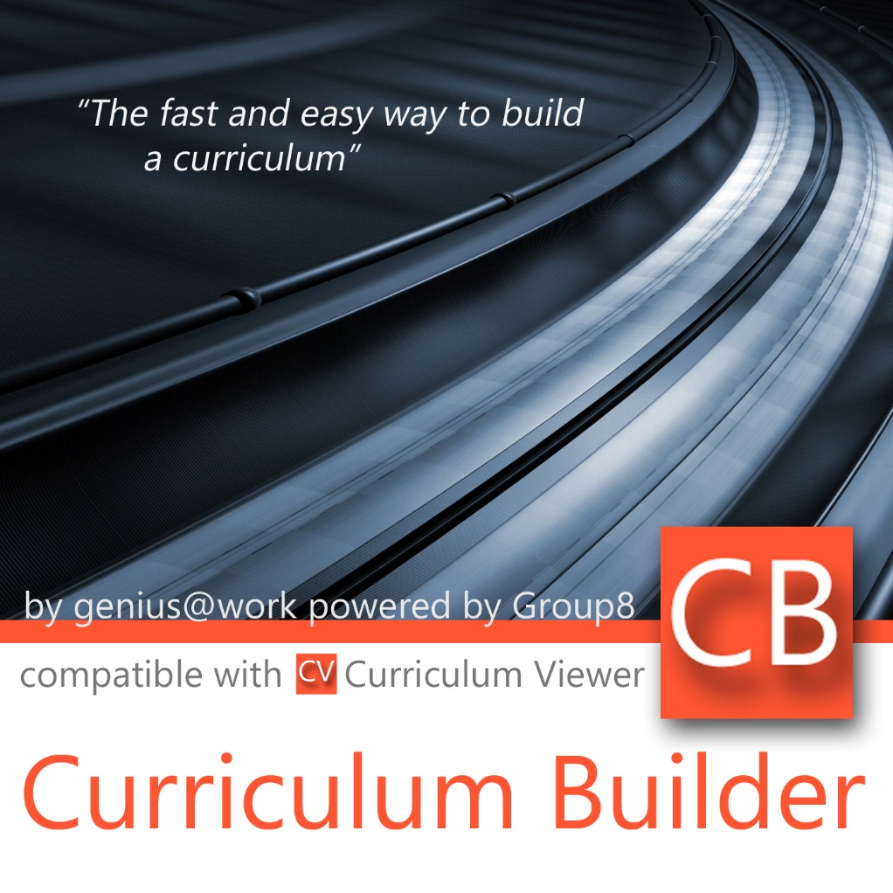

User Manual

**Log in**  
You have to log in to use the Curriculum Builder software. Enter a valid username and password and click on the **Login** button or press **Enter** on your keyboard.

**Log out**   
If you want to log out, use **File > Logout** in the menu-bar at the top of the window.

**Quit**  
To quit Curriculum Builder, use **File > Quit** or close the window manually.

Upon an important event, the text in the status bar will change.

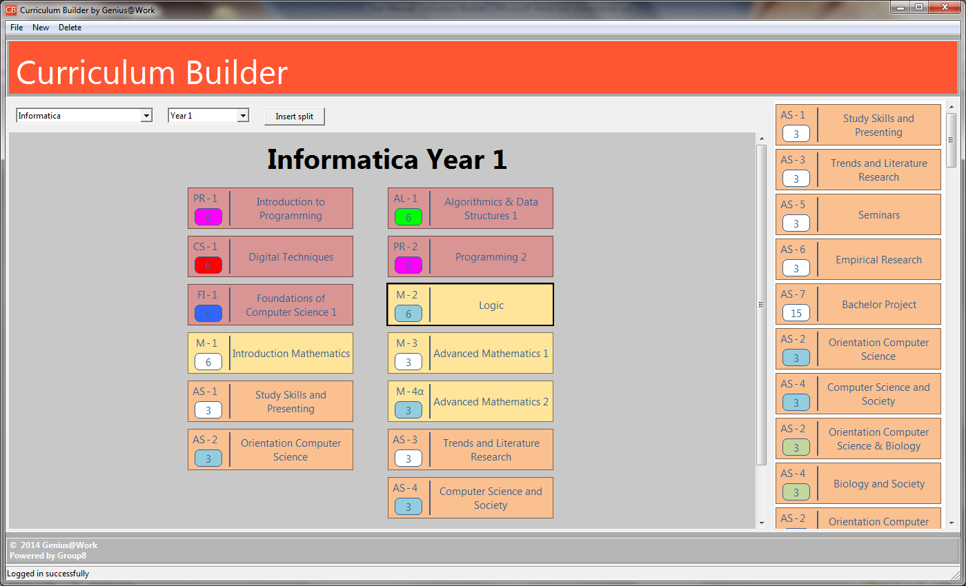  
Create a Curriculum

This program has been designed to easily create Curricula. You can create a curriculum by adding Study programs. These Study programs can include several Years, existing of several Courses.  
  
Study Programs

You can add a Study Program to your Curriculum or delete a Study Program from you Curriculum.

**Select study program**  
To select one of the available Study programs, you can click on the desired Study Program in the drop-down menu on the left side of the window. This menu always shows the Study program that is currently visible and ready to be edited.

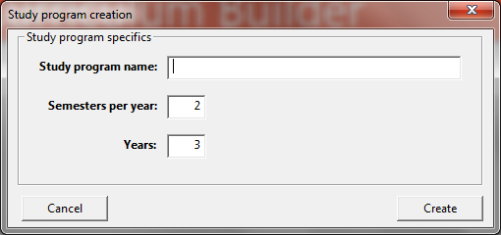

**New study program**  
To add a **New study program**, use **New > New study program** in the menu-bar at the top of the window. A pop-up appears where you can set the **Study program name**, the amount of **Semesters per** **year** and the amount of **Years** for this Study program. Choose **Create** to summit the Study program to you Curriculum, or click **Cancel**. If you **Cancel** the **New study program** or close the pop-up window manually before clicking **Create**, your Study program will not be saved to the Curriculum.  
 **Edit study program**  
It is not possible to **Edit** a study program. If you made a mistake creating a **New study program**, you can **Delete** this Study Program and add a **New study program** to your Curriculum.  
  
**Delete study program**  
To delete a study program from you Curriculum, use the **Delete > Delete study program**, in the menu-bar at the top of the window. Pick the desired Study program from the drop-down menu, in the pop-up screen that appears. Click **Delete** to confirm deleting this Study program, or click **Cancel** to cancel deleting.

Years

You can add a New Year to a Study program, select a Year or Delete a Year form a Study program.

**Select year**  
To select a year, you will have to select the desired Study program first. This selection will always show the first year of the program on your screen. If you want to select another year to view or edit, use the second drop-down menu from the left. The menu always shows the Year that is currently visible.   
  
**New year**  
You can add a Year to the selected Study program by using **New > New year** in the menu-bar at the top of the window. A pop-up screen will appear where you can set the **Study Program** and the **Year** you want to add. Please be aware of the fact that you can create two or more years with the exact same name, for example YEAR 1. Both years will be treated by the Curriculum Builder as independent and unique years.  
  
**Delete year**  
If you want to delete a year from your Curriculum, you can use **Delete > Delete year**. A pop-up screen will appear where you can select both the **Study program** and the **Year**. Once selected, you can delete this year by using the **Delete**-button on the right side of the pop-up screen.  
If you want to cancel, click **Cancel** or close the pop-up screen manually. The year will not be deleted from your Curriculum.

Courses

All possible courses are displayed in the Course Library at the right side of the window. You can add a new course to the Course Library, edit an existing Course of delete one of the Courses.

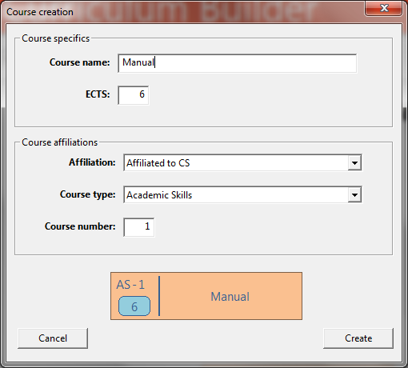

**New course**  
You can add a **New course** by using **New > New course** in the menu-bar at the top of the window. A pop-up screen will appear, where you can set the Course specific information and the Course affiliations. At the bottom of the pop-up screen a preview of the **New course** you are about to create is shown. To summit a **New course** to the Course Library, use the **Create**-button at the bottom of the pop-up screen. To cancel, click **Cancel** or close the pop-up window manually.  
  
**Edit a course**  
By double clicking on a Course in the Course Library, you can **Edit** the Course information. A pop-up, similar to the one at **New > New course**, will appear, where you can change the Course information. You can summit your changes to the Course Library by using the **Edit**-button. Click **Cancel** to close the pop-up screen without summiting your changes to the Course.

**Delete a course**   
To Delete a course, double click on a Course in the Course Library. The **Edit**-pop-up will appear. At the bottom of the pop-up screen, right in between the **Cancel**- and the **Edit**-button is a **Delete**-button. Click this button to delete a Course from the Course Library, and from all years that included this Course.

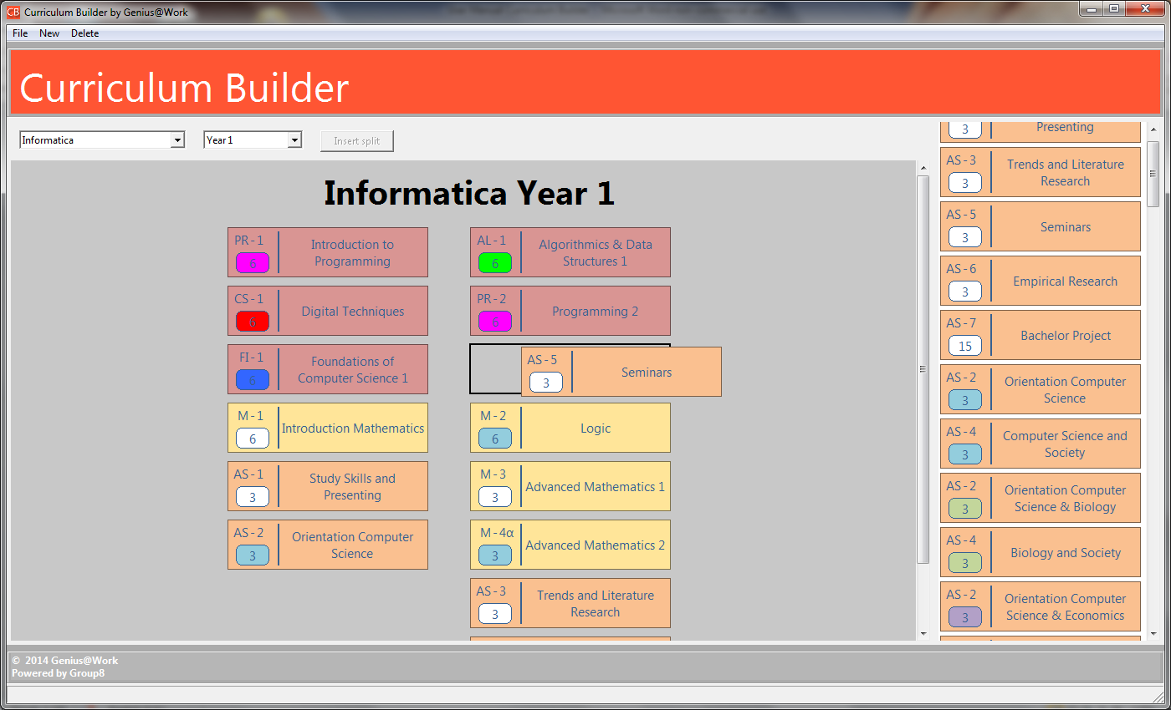

**Add a Course to your Curriculum**You can add a Course simply by a Drag-and-Drop principle. Make sure you have selected the right **Study program** and **Year** first. Click on the Course in the Course Library on the right side of the window and drag the subject into the Curriculum.  
  
**Remove a Course from your Curriculum**You can remove a Course from you Curriculum by dragging the Course back to the Course Library. The Course will not be removed from other years or the Course Library.

Insert a Split

You can use a split to show a choice in Courses in this year.

**Insert split**  
First select the desired **Study program** and **Year**. Add one of the optional **Course**s (we will refer to this course by “Course A”) to your Curriculum. Adding this Course at the bottom of the list of Courses will help your Curriculum stay organized. Once Course A is added, select it by clicking on this Course in the Curriculum. Now you can use the **Insert split**-button right above the Curriculum. Course A will move aside, to make room for the other optional Course (Course B). You can finish the split by dragging Course B into your Curriculum, next to Course A. To show a split with more than two optional Courses, select one of the current optional Courses and use Insert split again. You can add another Course next to or right under the current optional Courses.   
Note: Ensure that all parties involved are aware of the interpretation of splits.

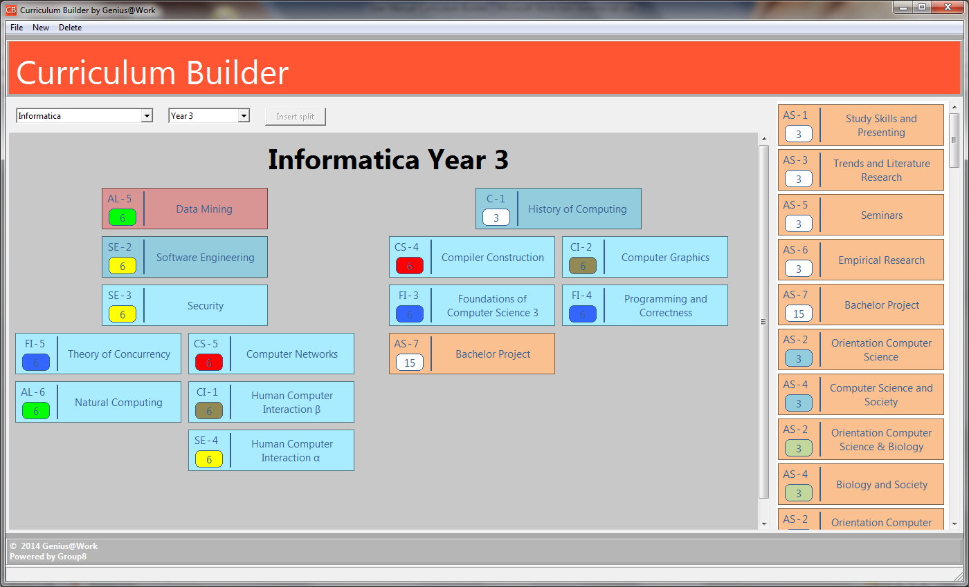

Save your Curriculum

There is no need to save your Curriculum while working on it or saving it manually once it’s saved. The Curriculum Builder will save your Curriculum every time a change is applied. The next time you’ll be using Curriculum Builder, you’ll find your Curricula exactly the way you left them.

Export your Curriculum

**Export a Curriculum**  
To export your Curriculum to the Online Curriculum Viewer, you can use **File > Export** in the menu-bar at the top of the window.